Latest News Page Updates | 

Information for the Web Team at Leigh Academies Trust

Please submit items for the academy's website news page. The news page is published every Friday at 12:00. Senior Leadership Team (SLT) members must submit their items by 17:00 on Thursday for inclusion that week. There is no need to write full stories, as all submissions will be rewritten to maintain a consistent style and format. Instead, please provide concise bullet points covering the following details:
- Who was involved, including both staff and students
- What the event was
- Where the event took place
- When the event occurred
- Why the event was organised
- A relevant quote
- Any accompanying pictures

Latest News Page Updates | Friday, 6 March 2026

A Message from the Deputy Principal
Dear Leigh Stationers’ Academy Community,

It has been another positive week at Leigh Stationers’ Academy. Thank you to all pupils, parents and carers who attended our Key Stage 4 Options Evening; it was excellent to see so many families engaging with subject teachers and pupil ambassadors as Year 9 pupils begin to consider their next steps. This week also saw pupils in Years 7, 8 and 9 celebrate World Book Day through this year’s ‘Go All In’ theme, with staff dressing as fictional heroes and villains and pupils discussing The Pedestrian by Ray Bradbury. In addition, our Year 10 rugby team represented the academy superbly at the U15 Kent Rugby 7s Tournament, finishing second in their group and reaching the Shield Final, while National Careers Week has provided valuable inspiration and guidance for pupils across the academy.

Looking ahead, I would encourage families of Year 7 pupils, and those new to Years 8 and 9, to sign up for Monday’s MYP Coffee Morning, which will offer helpful guidance on assessment and reporting within the IB Middle Years Programme. I would also remind Year 9 families to look out for the Key Stage 4 Options Form as we move into the final stage of the options process. Thank you, as ever, for your continued support and commitment to academy life.

Here’s to another great week at LSA!

Best wishes,
Mrs Rachel Dooley | Deputy Principal, Leigh Stationers’ Academy

KS4 Options Update: Supporting Year 9 Pupils with their Next Steps
Leigh Stationers’ Academy would like to thank all pupils, parents and carers who attended the Key Stage 4 Options Evening. It was a pleasure to see so many families speaking with subject teachers and pupil ambassadors to explore the qualifications and pathways available. The event marked an important stage in the options process for Year 9 pupils, and it was encouraging to see such thoughtful engagement as families began considering the choices ahead.

Throughout the week, pupils have also taken part in subject taster sessions and reflected on their future pathways during tutor time. As the process now moves into its final stage, the Key Stage 4 Options Form will be issued later today. Families are encouraged to use the information and resources available on the academy website to support discussions at home and help pupils determine their rank-order preferences.

Upcoming KS4 Options Dates
- Friday 6 March 2026 – KS4 Options Form Issued: The Google Form will be sent to parents and carers to submit KS4 preferences.
- Wednesday 18 March 2026 – Year 9 Parents’ Evening and Deadline: Parents’ Evening will take place, and this is the deadline for submitting the KS4 preferences form.
- Module 6 – Options Confirmed: The academy will confirm pupils’ KS4 options for the start of Key Stage 4.

World Book Day: Going All In on Reading
Leigh Stationers’ Academy celebrated World Book Day on Thursday, 5 March 2026, with pupils and staff embracing this year’s theme of ‘Go All In’. Staff joined in the occasion by dressing up as heroes and villains from fiction, helping to bring well-known characters and stories to life across the academy.

As part of the day, pupils in Years 7, 8 and 9 took part in a Read Throughout the Day activity, centred on The Pedestrian by Ray Bradbury. The short story prompted thoughtful discussion about the importance and power of reading, encouraging pupils to reflect on how literature can shape ideas, challenge perspectives and deepen understanding of the world around them.

Ms Efford said: “World Book Day was a wonderful opportunity to celebrate reading across the academy. It was fantastic to see staff and pupils embracing the theme so enthusiastically, and the discussions around The Pedestrian showed the value of reading in helping young people to think deeply, reflect and engage with important ideas.”

Photo Reel

Reminder: MYP Coffee Morning: Supporting Progress and Understanding Assessment
Leigh Stationers’ Academy is inviting parents and carers of Year 7 pupils, along with families of students who are new to Years 8 and 9, to attend an upcoming MYP Coffee Morning on Monday, 9 March 2026. The session will provide an overview of the IB Middle Years Programme (MYP) assessment framework and the academy’s reporting processes.
During the session, staff will explain how pupils’ progress is monitored, clarify how assessments are used to support learning, and outline how reports are structured. There will also be an opportunity for parents and carers to ask questions and gain practical guidance on how they can support their child’s learning at home.
- Date: Monday 9 March 2026
- Time: 08:30–09:15
- Location: Library, The Crown Building
- Sign up: HERE

Weekly Sports Update: Year 10 Kent Rugby 7s Tournament
On Thursday, 26 February 2026, Leigh Stationers’ Academy’s Year 10 rugby team represented the academy at the U15 Kent Rugby 7s Tournament at Eltham College.

The team produced an excellent performance throughout the competition, finishing second in their group to secure a place in the Shield Finals. A determined and hard-fought 19–14 victory against Canterbury Academy in the semi-final saw the boys progress to the final, with outstanding defensive efforts from Jack F and Harry L proving crucial at key moments. In the Shield Final, Leigh Stationers’ Academy were Shield Finalists, narrowly losing 19–26 to The Howard School in a closely contested match. The game featured excellent tries from Austin R and impressive tactical kicking from Ted E, reflecting the team’s resilience, skill and commitment throughout the tournament.

Mr Judd (Director of Learning for PE & Sport) said: “I was really pleased with the way the boys competed throughout the day. To finish second in the group and reach the Shield Final was a strong achievement, and they represented the academy with real resilience and commitment throughout. Ted E and Austin R were deserved Players of the Match for their impact across the tournament.”

Players of the Match: Ted E and Austin R

Team: Ted E, James M, Lucas C, Jack F, Max G, Alby J, Danny N, Austin R, Sam F, Cruz C, Harry L

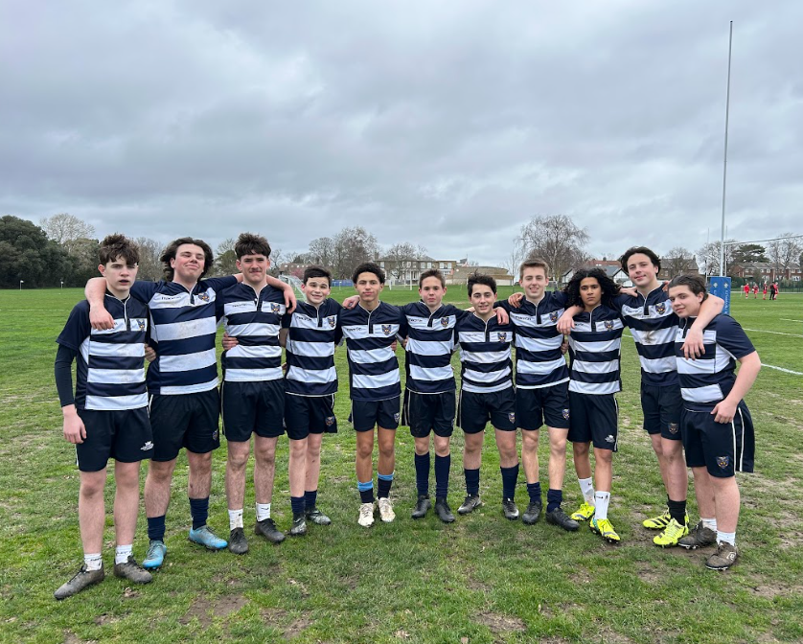

Digital Update: Understanding YouTube
YouTube is a video-sharing platform that allows billions of people around the world to watch, share and upload content across a wide range of topics, including sport, entertainment, education and much more. It provides users with easy access to videos aligned with their interests and has become one of the most influential platforms shaping online culture.
With its global reach, YouTube has also played a significant role in the growth of digital creators and online personalities, while offering young people opportunities to explore new ideas, skills and communities. However, as with any online platform, there are potential risks to be aware of. These may include interacting with strangers, exposure to inappropriate content and the challenges associated with high online visibility.
Mr Keable (Digital Lead) said: “YouTube can be an excellent learning and entertainment resource for young people, but it’s important that families understand how the platform works and encourage safe viewing habits. Taking time to review privacy settings, monitor content and have open conversations about what children are watching can make a real difference in helping them navigate the platform responsibly.”
In this guide, parents and carers can find practical advice on how to help young people use YouTube safely and responsibly.
Click HERE to access the guide.

CCF Update: George Heine’s Departure
This week marked George Heine’s final week at Leigh Stationers’ Academy, as he steps down from his role as the CCF School Staff Instructor. After five years of dedicated service to the academy and our cadets, George is moving on to an exciting new business opportunity. We thank him for his commitment and contribution to the life of the school and wish him every success in his next chapter.
Mr Sparks (Principal) said: “George has been an exceptional member of staff, dedicating himself wholeheartedly to the CCF and the development of our cadets. His enthusiasm, expertise and leadership have left a lasting impact on the academy community, and he will be greatly missed by pupils and staff alike. We wish him every success in the exciting opportunities ahead.”
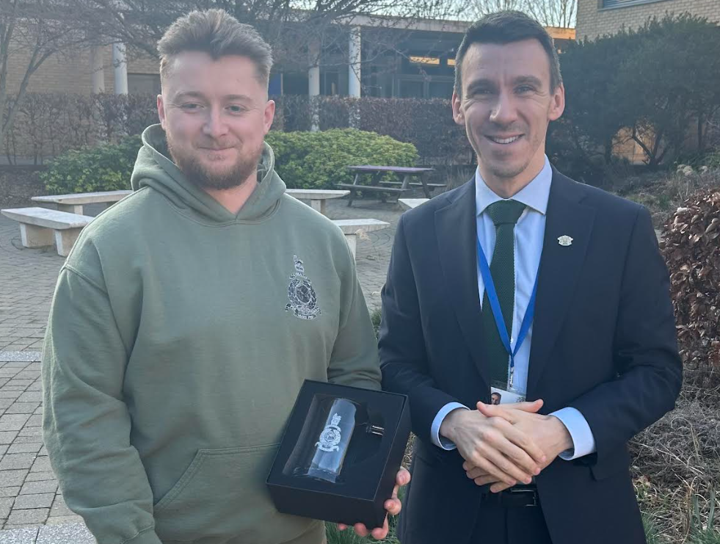

Reminder: GMHST Parent Webinars to Support Exam Stress
To support families during the exam season, the Greenwich Mental Health in Schools Team (GMHST) is hosting a parent webinar titled “Supporting your child with exam stress”. The session will explore how academic pressure can affect young people and provide practical strategies to help pupils manage stress, build resilience, and maintain wellbeing.
This is the second webinar in the series and will take place on Monday, 9 March 2026, from 18:00–19:00. Parents and carers are encouraged to join to gain guidance and resources to support their child during this busy time.
Full details are available here.

Personal Development Updates

PSHE Update: Supporting Personal Development Across Years 7-13
In Module 4, Personal, Social, Health and Economic (PSHE) education at Leigh Stationers’ Academy will focus on age-appropriate themes that support students’ well-being, personal growth, and preparation for life beyond the classroom. Each session is designed to encourage collaboration, critical thinking and skill development.

 | This Week | Next Week
Year 7 | National Careers Week | IB Community Project
Year 8 | National Careers Week | IB Community Project
Year 9 | National Careers Week | IB Community Project
Year 10 | Why are CVs important? | How can I write an effective cover letter to a potential employer?
Year 11 | Revision Strategies & GCSE Exam Preparation - Spaced Retrieval | Revision Strategies & GCSE Exam Preparation - Spaced Retrieval 2 of 2
Year 12 | Online Community: How can I manage my reputation online? | What does a stable and healthy relationship look like?
Year 13 | How can I ensure my online behaviour is respectful to others? | Online Community: How can I understand the importance of data privacy?

Careers Education: Weekly Information, Advice & Guidance
This week's Careers Newsletter highlights activities for National Careers Week, alongside competitions, scholarships, and opportunities in STEM and green industries..

- National Careers Week and Ongoing Support: With National Careers Week 2026 taking place from 02 – 08 March under the theme “Own Your Future”, students are encouraged to explore a virtual careers fair, use BBC Bitesize tools to match favourite school subjects to future careers, and watch apprentice story videos showcasing a wide range of apprenticeship pathways.
- Competitions and Scholarships: Students are invited to take part in national opportunities including the BAFTA Young Game Designers Award, the Canon Young Champion of the Year competition for those campaigning on social or environmental issues, and the Stephenson Harwood Law Scholarships which provide up to £15,000 per year plus mentoring and work experience for successful applicants.
- STEM, Tech, and Green Sector Opportunities: Students interested in science and technology can explore careers in the growing green sector through an upcoming webinar, access technology work experience through the Next Tech Girls initiative, and read Catalyst magazine, a science journal showcasing real-world research and developments written by STEM professionals.

Parents and carers are encouraged to read the newsletter with their child. Further support is available via careers@stationers.latrust.org.uk

Click HERE to read this week’s Careers Newsletter
Web team: Please make this box a button on the website.

Careers Exploration Series: Talk from Sharon Young MBE, WSP
In recognition of National Careers Week, we were delighted to welcome Sharon Young MBE from WSP, a global engineering consultancy, to speak to the full cohort of Year 7 and Year 8 students during a special assembly.
Sharon, a Director in the Rail Group at WSP, shared her inspiring career journey in rail engineering and spoke about her experience working on major railway and infrastructure projects, such as her work leading a team to develop Bond Street station as part of the Crossrail project. She gave students a fascinating insight into the work behind the rail stations and systems we use every day.
During the session, Sharon explained how she began her career, the subjects that helped her along the way, and the different pathways students can take into engineering, including apprenticeships and university routes. She also highlighted the wide range of opportunities within engineering, from designing stations and tunnels to working in sustainability, digital technology, and project management.
Students were highly engaged throughout the assembly, and Sharon’s passion for engineering and her encouragement to stay curious and open to new opportunities left a lasting impression.
Photo Reel

Reminder: Year 10 & 12 Work Experience
Work Experience Week for Year 10 and Year 12 will take place from Monday, 6 July to Friday, 10 July 2026. Students are expected to have secured a placement, and the deadline to log placement details on Unifrog has been extended until Friday, 13 March 2026.

How to Log a Placement on Unifrog: Once an employer has confirmed a placement verbally or by email, students should log this on Unifrog by:
- Launching Unifrog and scrolling down to the “Placements” tool.
- Clicking "Add a new placement."
- Completing the Student Initial Form with the employer’s contact details.

Helpful Resources:
- Unifrog's Placements tool FAQs – A short animation to get you started.
- How to Help Your Child Find a Placement – Tips for the search.
- Mr Smith’s Webinar – A full walkthrough of the school's expectations.

For queries, families should contact Ms Saif via careers@stationers.latrust.org.uk

Web Team: For the following events/insight days, please can you list them as a dropdown menu, in this style:
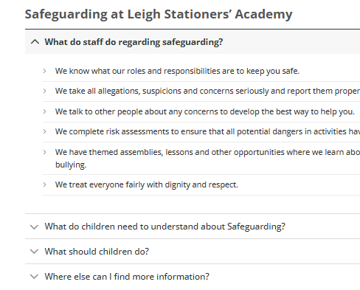

Careers Unlocked
Students are invited to join the "Careers Unlocked" series, featuring seven online workshops led by experienced industry professionals. These sessions provide essential guidance on breaking into highly competitive fields. Participants can earn a certificate of attendance to support future applications, and those unable to attend live can register to receive recordings and follow-up resources.
- Featured Workshops: Medicine, Law, Engineering, Entrepreneurship, Psychology, and Investment Banking.
- Format: Online Workshops
- Benefits: Certificates of attendance and session recordings provided.
- Register: Students can find out more information and register here

A Parent’s Guide to Life After School
This interactive webinar, the final session in the "Careers Unlocked" series, is specifically designed to help parents and carers navigate today’s competitive job market. The session provides practical guidance on supporting children with university applications, apprenticeships, and gaining meaningful work experience. Attendees will learn about current graduate trends and the essential skills students need to build now for future success.
- Date: Tuesday, 17 March 2026
- Time: 18:00
- Location: Online (Recording available for those who cannot attend live)
- Register: Students and parents can find out more information and register here

National Careers Week: Virtual Careers Fair
As a centerpiece of National Careers Week, students are encouraged to visit the NCW Virtual Careers Fair to continue the work many of them have started during tutor time this week. This digital platform allows students to explore a wide range of employment sectors, discover different career pathways, and connect with national employers and organizations. The fair is designed to be accessible from any device, providing videos, employer profiles, and interactive resources to help young people "own their future."
- Dates: Monday, 2 March – Saturday, 7 March 2026
- Time: Available 24/7 throughout the week
- Location: Online (No registration required)
- Features: Virtual booths for various industries, including green careers, healthcare, and technology.
- Register: Students can find out more information and access the fair here

Year 8 Growth Measurement Checks
As part of our ongoing commitment to pupil wellbeing, Leigh Stationers’ Academy is sharing an important letter from the Young Greenwich School Nursing team (Oxleas NHS Foundation Trust) regarding Year 8 Growth Measurement checks.
The checks will take place in school on Thursday, 26 March 2026, from 08:30. The letter outlines what will happen on the day, how privacy and confidentiality will be maintained, and provides guidance for parents and carers who wish to discuss the programme or opt their child out.
Families are encouraged to read the letter carefully and contact the nursing team directly with any questions or concerns.
Please read the full letter here.

